As we continue on our journey, I wanted to call your attention back to this image (below) from our first session together.  For those of you who are feeling frustrated by not having actions or answers, I encourage you to marinate in that that discomfort for a little while—particularly if you are in a position of power or privilege. For those of you whose lives have been impacted directly by systemic racism and other forms of oppression, you may have many emotions. If you wish to engage with others who have similar experiences, here is a reminder of some of the BIPOC affinity groups available here at UW:

We will get to action-oriented sessions, but first we will spend some time exploring US History & white supremacy culture. Part of developing solutions is understanding how we got here. Building historical understanding is a key component of critical consciousness.

As always, if you come from a background or hold an identity where this material will be harmful or redundant for you, you may opt out. If you come from a position of power/privilege, discomfort is an expected part of this work and you are urged to continue participation.

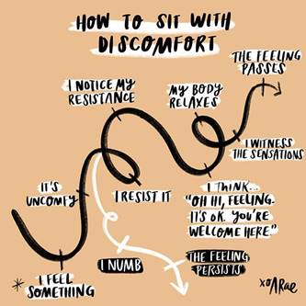

Consider taking the 10-question Health Equity Quiz, developed with the Unnatural Causes episode we watched (so it’s old, but if anything numbers have only gotten worse): <https://unnaturalcauses.org/interactivities_01-1.php>

More info on redlining, for those of you who are interested: Redlining in general and then specific MKE, also references Madison (audio only): <https://www.wpr.org/listen/1428086> (run time 11:52)

*(this is from a WPR story)*